**Section 28 – Moving To A Real Development Workflow With Webpack**

Chapter 406 – Chapter 416

1. A Case For A Development Server

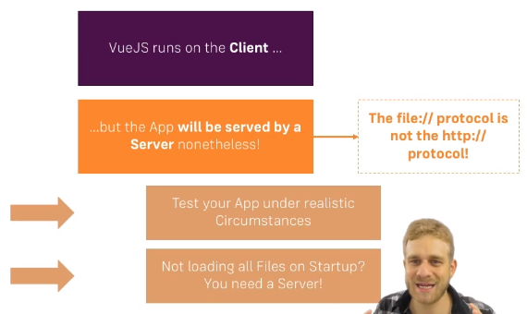

1. What is a “Development Workflow” ?  
    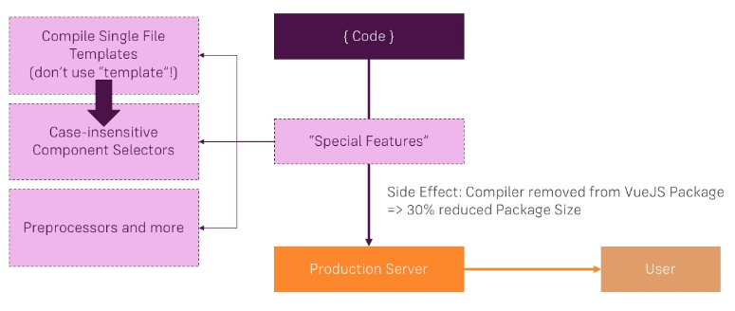
2. What is the Vue CLI and Template Compilation ? Except the first one

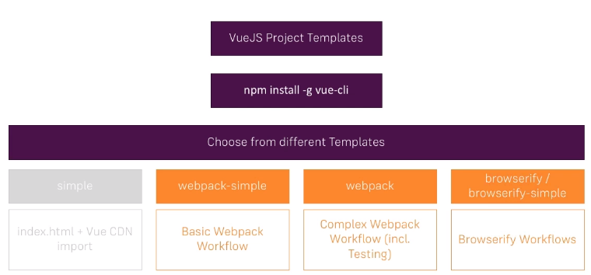

1. To create a project using node js

vue init webpack-simple vue-cli

npm install

npm run dev

npm run build